Day 11 NodeJS Introduction & Environment Setup

Node JS
Node JS – It’s a free open source, event-driven, Cross-platform, Single Threaded, JS runtime environment created using Google’s chrome v8 Engine.
Why – To run Javascript anywhere (inside/outside the browser, client/server side, stand-alone/web-application)
It consist of many modules.

Official Site - https://nodejs.org/en
(download LTS version Long Term Support – Stable version) 24.11.1 (5-Dec-2025)

MEAN – MongoDB, Express, Angular, NodeJS.

Setting up the Environment – (Adding all necessary tools & making sure it’s available from any location)
Installing Node JS –
- Open command prompt (win+r cmd)
- Enter the following command – “node -v”
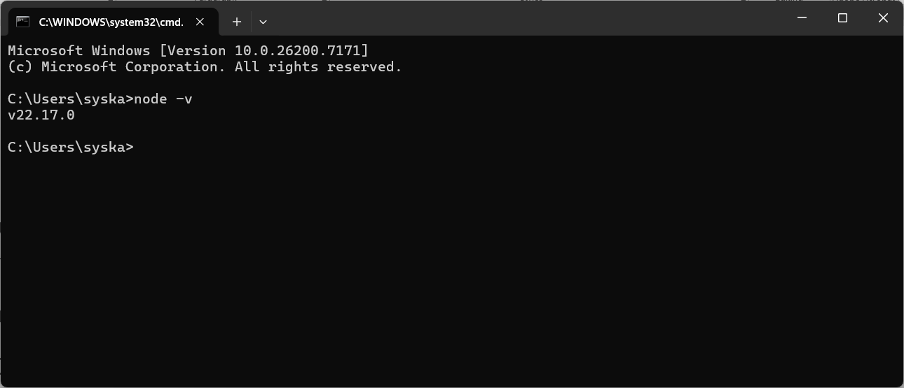
- If it’s not showing the version as above download & install it from official site. (https://nodejs.org/en/download )
- Make sure, node is accessible from all the locations (Add to path) -- Environment variables (Either User Level or System level environment variable)
- Echo %JAVA_HOME% -- prints the value of Environment variable JAVA_HOME

Modules of NodeJS
- Core Modules
- Local Modules (User defined modules with an ext .mjs)
- 3rd Party Modules (external)

Core Modules
- fs - File system operations
- http - HTTP server and client
- path - File path utilities
- os - Operating system utilities
- events - Event handling
- util - Utility functions
- stream - Stream handling
- crypto - Cryptographic functions
- url - URL parsing
- querystring - URL query string handling
To use any built-in module, use the require() function:
Example: Using Multiple Built-in ModulesGet your own Node.js Server
const http = require('http');

. – represents the current folder (relative path)
.. – represents the parent folder (relative path)

- Core Modules: These are built-in modules that come pre-compiled with the Node.js binary. They provide essential functionalities like file system operations (fs), HTTP server creation (http), and event handling (events). They do not require separate installation and are accessed directly using require().
JavaScript
const http = require('http');
- Local Modules: These are custom modules created by the developer within a specific Node.js project. They are used to encapsulate application-specific logic, functions, or data. Local modules are typically defined in separate .js files and exported using module.exports or exports, then imported into other files using require() with a relative path.
JavaScript
// myModule.js
exports.greet = (name) => `Hello, ${name}!`;
// app.js
const myModule = require('./myModule');
console.log(myModule.greet('User'));
- Third-Party Modules: These are external libraries or packages developed by others and published to package managers like npm (Node Package Manager). They offer a vast ecosystem of pre-built solutions for various tasks, from web frameworks (e.g., Express.js) to database connectors. Third-party modules are installed into the node_modules directory and imported using their package name.
JavaScript
// Install a third-party module (e.g., 'lodash')
// npm install lodash
// app.js
const _ = require('lodash');
const array = [1, 2, 3];
console.log(_.reverse(array)); // Output: [3, 2, 1]
Node.js supports two module systems: CommonJS (the original) and ECMAScript modules (ESM). The choice of system impacts how modules are defined and imported, with .mjs file extensions or package.json "type": "module" indicating ESM, and .cjs or "type": "commonjs" indicating CommonJS. When no explicit marker is present, Node.js attempts to infer the module system based on syntax

ES – ECMA Scripts
EMS – ECMA script Module System
CMS – Common JS Module System

Localhost – ipaddress – 127.0.0.1
“netstat -a | findstr ‘3000’”

NodeJS Official Doc - https://nodejs.org/docs/latest/api/

File Handling operation
Sync Mode (Blocking)
const fs = require('fs');

// Create a dummy file for demonstration
try {
fs.writeFileSync('example.txt', 'Hello from Node.js readFileSync!');
} catch (err) {
console.error('Error creating example.txt:', err);
}

try {
// Read the content of 'example.txt' synchronously
// Specify 'utf8' encoding to get a string; otherwise, a Buffer is returned.
const fileContent = fs.readFileSync('example.txt', 'utf8');

console.log('File content:', fileContent);
} catch (err) {
// Handle any errors that occur during file reading
console.error('Error reading file:', err);
}

Async Mode (Non-Blocking)
const fs = require('fs');

fs.readFile('input.txt', 'utf8', (err, data) => {
if (err) {
console.error('Error reading file:', err);
return;
}
console.log('File content:', data);
});

NPM – Node Package Manager (It’s a package manager for Node – Adds necessary libraries and modules to our nodejs based application)

While installing nodeJS npm is also installed along side.

Official Site - https://www.npmjs.com/

Installing Dependencies using NPM
  - Global Installation
  - Local Installation

Checking NPM version
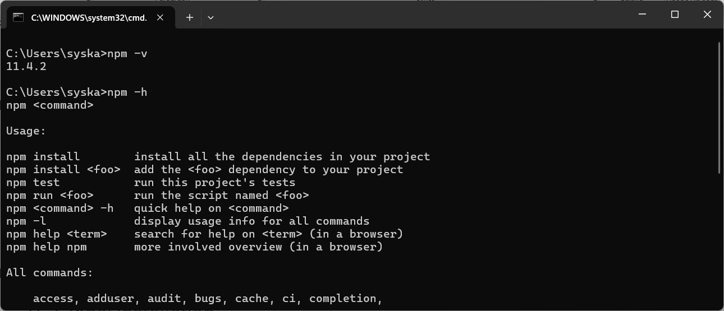

Npm install – this command will search a file named package.json. If it’s present in the folder it will check the dependencies section and download all the necessary tools and keep them inside a folder namely “Node_modules”

“npm install” or “npm I” - Local installation
“npm install --global” or “npm I -g” -- Global Installation (%USER_PROFILE%\AppData\Roaming\npm\node_modules )

Interacting with MongoDB using nodejs (npm I mongodb)

const { MongoClient } = require('mongodb');

async function findOneExample() {
const uri = "mongodb://localhost:27017";
// Replace with your MongoDB connection string
const client = new MongoClient(uri);

try {
await client.connect();
const database = client.db("mydb"); // Replace with your database name
const collection = database.collection("customers");
// Replace with your collection name

// Example 1: Find a document by a specific field
const query1 = { name: "test" };
const user1 = await collection.findOne(query1);

if (user1) {
console.log("Found user by name:", user1);
} else {
console.log("User 'test' not found.");
}

// Example 2: Find a document by _id (requires ObjectId conversion)
const ObjectId = require('mongodb').ObjectId;
const userId = new ObjectId("69327e70c93fc25b47090a4a");
// Replace with a valid _id
const query2 = { _id: userId };
const user2 = await collection.findOne(query2);

if (user2) {
console.log("Found user by _id:", user2);
} else {
console.log("User with specified _id not found.");
}

// Example 3: Find a document with projection (include/exclude fields)
const query3 = { age: { $gte: 30 } };
const projection = { name: 1, email: 1, _id: 0 };
// Include name and email, exclude _id
const user3 = await collection.findOne(query3, { projection });

if (user3) {
console.log("Found user by age with projection:", user3);
} else {
console.log("User aged 30 or more not found.");
}

} finally {
await client.close();
}
}

findOneExample().catch(console.error);

